

**SR IIT SPARK IC & NIPL SUPER -60 EAMCET MODEL Ex. Date:- 01.10.2022**

**Time: 3 Hrs. Max. Marks: 160**

**MATHS**

1. If ,then 

1)  2) 3) 4) 

2. The sum of the series up to 200 terms equals

1)  2)  3) 4) 

3. The value of terms=

1)  2) 3) 4) 

4. If and are two pairs of conjugate complex numbers, then arg+argequals

1) 2) 3) 4) 

5. If ‘z’ lies on the circle =,then the value of argis equal to

1) 2) 3) 4) 

6. Ifis purely imaginary number then  is equal to

1) 2) 3) 4) 1

7. The multiplicative inverse of z is

1) 2) 3) 4) 

8. If ,then the maximum value of  is

1) 2) 3) 4) 

9. If then the range of value ofis

1) 2) 3) 4) 

10. Ifthen 

1) 2) 3) 4) 

11. 

1) 2) 3) 4) 

12. 

1) 2) 3)  4) 

13. Iflies in the third quadrant, then also lies in the third quadrant if

1) 2) 3) 4) 

14. The complex number represented by the point P in argand plane and OP is rotated an angle of in counter clock wise direction then the resulting complex number is

1) 2) 3)  4) 

15. Let and be two complex numbers such that and arg.Then argis

1) 2) 3) 4) 

16. The condition for the cube of a+ib to be a real number is

1)or 2)or

3)or 4) or

17. If then the modulus argument formis

1)

2) 

3)

4) 

18. If then

1) 2) 3) 4) 

19. 

1) 2) 3) 4) 

20. 

1)  2) 3) 4) 

21. The point’sform_______ in argand plane

1) Rectangle 2) Rhombus 3) Square 4) None

22. Let be three points forming a triangle ABC in the Gussain plane then triangle ABC is

1) Equilateral 2) isosceles 3) scalene 4) Right angled

23. If Arg then the locus of z is

1) Circle with radius 2 2) circle with radius 1 3) straight line 4) pair of lines

24. The locus of the point satisfying the equationis given by

1) 2) 3) 4) 

25. If , then z lies on

1) A straight line 2) A square 3) A circle 4) Parabola

26. If then the locus of z is

1) a circle with centreand radius 25

2) a circle with centreand radius 25

3) a circle with centreand radius 5

4) a circle with centreand radius 5

27. If z is a complex number, thenrepresents

1) a circle 2) a straight line 3) a hyperbola 4) an ellipse

28. If Amp then the locus of is

1)

2)such that 

3)such that

4)  Such that 

29. Vector is rotated at angle in anti clock wise direction and its length is increased to two and half times. In new position z is

1)  2) 3) 4) 

30. If then the value of 

1) 2) 3) 4) 

31. If n is an integer andthen=

1) 2) 3) 4) 

32. If are the roots of the equation and then 

1) 64 2) 32 3) -32 4) -64

33. If , then

1) 2) 3) 4) 

34. If is a non-real root of then

1) 2) 3) 4) 

35. The value ofis

1) -1 2) -i 3) i 4) 1

36. is equal to

1) 132 2) 64 3) -64 4) -132

37. If then

1) 2) 1 3) 4) -1

38. Product of 4th roots of unity is

1) 2 2) 0 3) 1 4) -1

39. If where  denotes the continued product, then the most general value of is

1)  2) 3)  4) 

40. One vertex of an equilateral triangle is at the origin and the other two vertices are given by then k is

1) 2) 3) 4) 

41. Equation of the hyperbola with eccentricityand foci atis:

1) 2) 3) 4) None of these

42. Equation of the locus of all points such that the difference of its distances from (-3,-7), (-3,3) is 8 is

1) 

2) 

3) 

4) 

43. The equation of the hyperbola whose vertices are and one of the directrices is x=4

1)  2)  3)  4) 

44. Normal at  on meets the curve again at then 

1) 1 2) 2 3) -1 4) -2

45. The equation to the conjugate hyperbola of is

1)  2) 

3) 4) 

46. If the equation to the hyperbola is then the equation to the conjugate hyperbola is

1)

2)

3) 

4) 

47. The foci of the hyperbola with vertices at and  is

1)  2)  3)  4) 

48. If P is a point on the rectangular hyperbola , “C” is its centre and are foci then 

1) 2 2)  3)  4) 

49. The eccentricity of the hyperbola is

1)  2)  3)  4) 

50. If is the eccentricity of a hyperbola then the eccentricity of the conjugate hyperbola is

1)  2)  3)  4) 

51. The eccentricity of a hyperbola is then its length of latusrectum is

1)  2)  3)  4) 

52. Equation of the transverse axis of the hyperbola is

1)  2)  3)  4) 

53. Equation of one of the latusrectum of the hyperbola is

1)  2) 

3)  4) 

54. The centre , one vertex ,one focus of a hyperbola are its directrices are

1)  2) 

3)  4) 

55. The foci of the hyperbola are, . If its e=2 then the equation of its directrix corresponding to focus S is

1)  2)  3)  4) 

56. The condition that the line to be tangent to is

1)  2)  3)  4) 

57. If is a tangent to then the eccentric angle of the point of contact is

1)  2)  3)  4) 

58. The product of the perpendiculars from the foci on any tangent to the hyperbola is

1)  2)  3)  4) 

59. If the line is normal to the hyperbola, then

1)  2)  3)  4) 

60. Equation of the common tangent to and is

1)  2)  3)  4) 

61. Equation of the chord of the hyperbola, which is bisected at the point (6,2) , is

1)  2)  3)  4) 

62. The locus of middle points of chords of hyperbola parallel to  is

1)  2)  3)  4) 

63. The equation of the director circle of the hyperbola is

1)  2)  3)  4) does not exist

64. If the tangent at the point on the hyperbola meets the auxiliary circle of the hyperbola in two points whose ordinates then 

1)  2)  3)  4) 

65. A hyperbola, having the transverse axis of length, is confocal with the ellipse. Then its equation is

1)  2) 

3)  4) 

66. If two distinct tangents can be drawn from the point on different branches of the hyperbola, then

1) 2) 3) 4) 

67. For hyperbola, Let n be the number of points on the plane through which perpendicular tangents are drawn which of the following is not true

1) If, then  2) If, then 

3) If , then  4) If , then 

68. The chord of the hyperbola, whose equation is, subtends a right angle at it centre and it always touches a circle of radius

1)  2)  3)  4) 

69. If two points P and Q on the hyperbola, which centre C be such that CP is perpendicular to CQ, then is equal to

1)  2)  3)  4) 

70. If the equation represents a pair of conjugate diameter of the hyperbola, then

1)  2)  3)  4) 

71. A ray emanating from the point is incident on the hyperbola at the point P with abscissa 8 , then the equation of the reflected ray after first reflection is

1)  2) 

3)  4) 

72. If the circle intersects the hyperbola  in four points, for and 4, then 

1) 0 2) c 3) a 4) 

73. The eccentricity of the hyperbola is

1)  2)  3)  4) 

74. The equation of the hyperbola whose foci are  and  and eccentricity is 2is given by

1) 2) 

3)  4) 

75. A hyperbola passes through a focus of the ellipse .Its transverse and conjugate axes coincide respectively with the major and minor axes of the ellipse. The product of eccentricities is 1. Then the equation of the hyperbola is

1)  2)  3)  4) 

76. The equation of a tangent to the hyperbola parallel to the line is

1)  2)  3)  4) 

77. If is the chord of contact of the hyperbola, then the equation of the tangent at one of the points of contact is

1)  2) 

3)  4) 

78. The angle between the symptotes of the hyperbola of the hyperbola is

1)  2)  3)  4) 

79. If the line is a normal to the hyperbola, then is equal to

1)  2)  3)  4) 

80. The mid-point of the chord of the hyperbola is

1)  2)  3)  4) 

**PHYSICS**

81. Two point charges Q and -3Q are placed some distance apart. If the electic field at the location of Q is, the field at the location of -3Q

1) 2) 3) 4) 

82. Figure shows the electric lines of force emerging from a charged body. If the electric field at ‘A’ and ‘B’ are and respectively and if the displacement between ‘A’ and ‘B’ is ‘r’ then

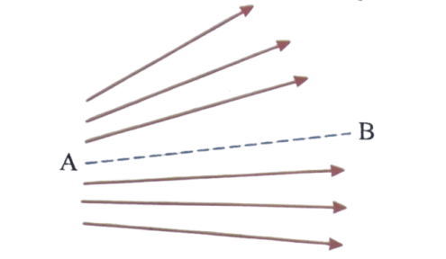

1) 2) 3) 4) 

83. A point charge C is located in the x-y plane at the position vector. The electric field at the point of position vector, in vector form is equal to:

1)  2)

3) 4) 

84. The property of the electric line of force

a) The tangent to the line of force at any point is parallel to the direction of ‘E’ at the point

b) No two lines of force intersect each other

1) Both a & b 2) only a 3) only b 4) a or b

85. AB is wire in the form of an arc as shown with linear charge density. If ‘O’ is the centre, and at ‘O’ are

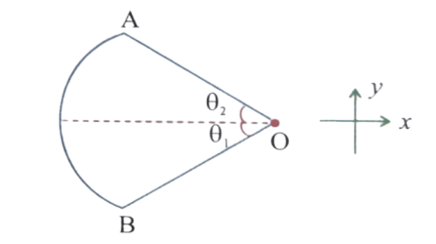

1)

2)

3)

4) 

86. Intensity of electric field inside a uniformly charged hollow sphere is

1) Zero 2) non zero constant

3) Change with r 4) inversely proportional to r

87. A proton of mass ‘m’ charge ‘e’ is released from rest in a uniform electric field of strength ‘E’. The time taken by it to travel a distance‘d’ in the field is

1)  2) 3) 4) 

88. A mass m carrying a charge q is suspended from a string and placed in a uniform horizontal electric field of intensity E. The angle made by the string with the vertical in the equilibrium position is

1) 2) 3) 4) 

89. An electron of mass ‘M’ kg and charge ‘e’ coulomb travels from rest through a potential difference of ‘V’ volt. The final velocity of the electron is (in m/s)

1) 2) 3)  4) 

90. When an electron approaches a proton, their electro static potential energy

1) Decreases 2) increases

3) Remains unchanged 4) all the above

91. An infinite number of charges each equal to ‘q’ are placed along the X-axis at x=1, x=2, x=4, x=8… The potential at the point x=0 due to this set of charges is

1) 2) 3) 4) 

92. A charge ‘Q’ is placed at each corner of a cube of side ‘a’. The potential at the centre of the cube is

1) 2) 3) 4) 

93. Figure shows three circular arcs, each of radius R and total charge as indicated. The net electric potential at the centre of the curvature is

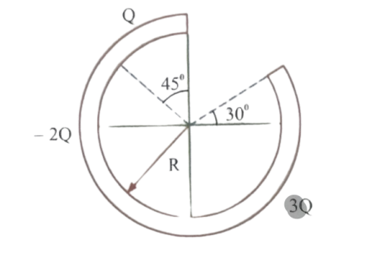

1) 2) 3) 4) 

94. An oil drop carrying charge ‘Q’ is held in equilibrium by a potential difference of 600V between the horizontal plates. In order to hold another drop of twice the radius in equilibrium a potential drop of 1600V had to be maintained. The charge on the second drop is

1) 2) 3) 4) 

95. In the figure shown, the electric filed intensity at r=1m, r=6m, r=9m in is

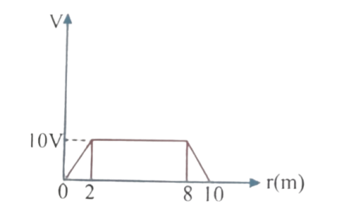

1)  2) 3) 4) 

96. A particle of mass m and charge q is fastened to one end of a string fixed at point O. The whole system lies on a frictionless horizontal plane. Initially, the mass is at rest at A. A uniform electric field in the direction shown is then switched on. Then

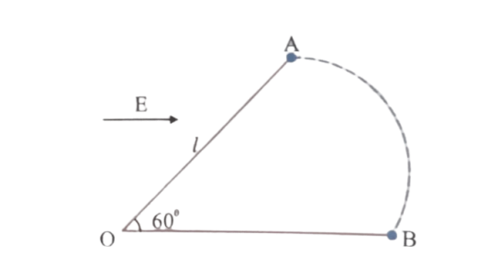

1) The speed of the particle when it reaches B is

2) The speed of the particle when it reaches

3) The tension in the string when particles reaches at B is 

4) The tension in the string when the particle reaches at B is qE.

97. The electric field at a point at a distance r from an electric dipole is proportional to

1) 2) 3) 4) 

98. If be the electric field at a point on the axis and be that on the perpendicular bisector at the same distance from the dipole, then

1)  2) 3) 4) 

99. If a hemispherical body is placed in a uniform electric field E then the flux linked with the curved surface is

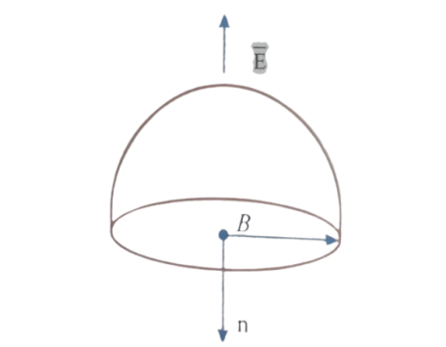

1) 2) 3) 4) 

100. The electric field intensity due to a uniformly charged infinite cylinder of radius R, at a distance r (>R), from its axis is proportional to

1) 2) 3) 4) 

101. A point charge +Q is located at a distance of r from the centre of an uncharged conducting sphere of radius R. The electric potential of that sphere is_____

1) 2) 3) 4) 

102. A conducting sphere of radius R is cut into two equal halves which are held pressed together by a stiff spring inside sphere. The change in tension in the spring if the sphere is given a charge Q

1) 2) 3) 4) 

103. A steady current is passing through a linear conductor of non uniform cross-section. The net quantity of charge crossing any cross section per second is

1) Independent of area of cross-section

2) Directly proportional to the length of the conductor

3) Directly proportional to the area of cross section.

4) Inversely proportional to the area of the conductor

104. Among the following dependences of drift velocity on electric field E, Ohm’s law obeyed is

1) 2) 3) 4) =constant

105. If the electron in a hydrogen atom makes revolutions in one second, the current is

1) 2)   3)  4) 

106. A copper wire of cross-sectional area 2.0, resistivity , carries a current of 1 A. The electric field in the copper wire is

1) 2) 3) 4) 

107. If n, e, , m, are representing electron density, charge, relaxation time and mass of an electron respectively then the resistance of wire of length 1 and cross sectional area A is given by

1) 2) 3) 4) 

108. The electric intensity E, current density j and conductivity  are related as:

1) 2) 3) 4) 

109. When a piece of aluminium wire of finite length is drawn through a series of dies to reduce its diameter to half its original value, its resistance will become

1) Two times 2) Four times 3) Eight times 4) Sixteen times

110. The resistance of a wire of 100 cm length is 10. Now, it is cut into 10 equal parts and all of them are twisted to form a single bundle. Its resistance is

1) 2) 3) 4) 

111. Two conductors have the same resistance at but their temperature coefficients of resistance are and. The respective temperature coefficients of their series and parallel combinations are nearly

1)  2) 3) 4) 

112. S resistances of each 12 ohm are connected as shown in the fig. The effective resistance between the terminals A and B is

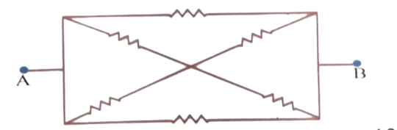

1) 2) 3) 4) 

113. Five point charges each of value +q are placed on five vertices of a regular hexagon of side ‘a’m. What is the magnitude or electric field at the centre of hexagon?

1) 2) 3) 4) 

114. A thin semicircular ring of radius ‘r’ has a positive charge q distributed uniformly over it. The net field E at the centre ‘O’ is

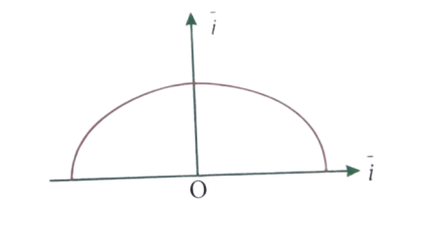

1)  2) 3) 4) 

115. A particle of mass m and charge q is placed at rest in a uniform electric field E and then released. The kinetic energy attained by the particle after moving a distance y is

1)  2) 3) 4) 

116. If ‘A’ and ‘B’ are two points at a perpendicular and from an infinite line charge of linear charge density then is

1) 2) 3) 4) 

117. Relation between current in a conductor and time is shown in

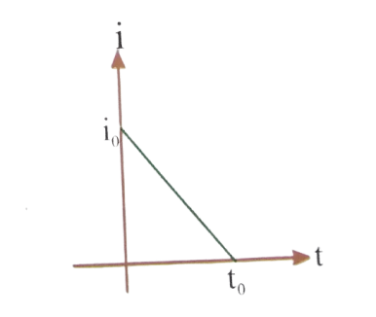

Write the expression of in terms of time

1)  2) 3) 4) 

118. Current flows through the given. Which of these quantities remains constant throught the complete length of a conductor

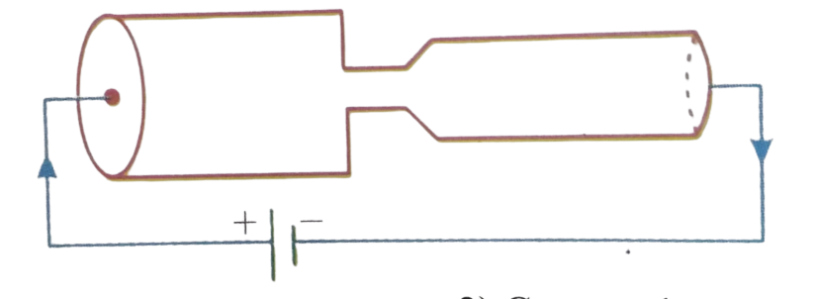

1) Current 2) Current density 3) Electron mobility 4) Electric field

119. A straight cylindrical wire lying along x-axis has length of 0.5 m and diameter of 0.2mm. It has a resistivity let potential of 4V is maintained at at Current in the wire.

1) 6A 2) 7A 3) 6.28A 4) 3.14A

120. Resistance of each are connected as shown in the fig. the effective resistance between A and G is

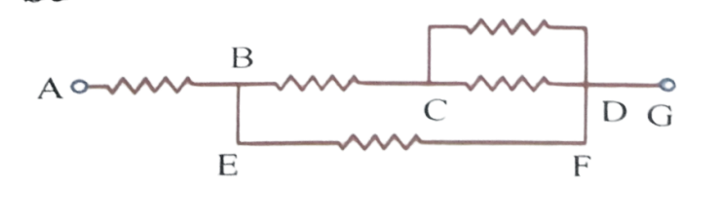

1.  2) 3) 4) 

**CHEMISTRY**

121. Reactivity of .And is in order (towards nucleophilic addition)

1) 2) 3) 4) 

122. 

The above reaction is known as

1) Aldol condensation 2) Clemmenson’s reduction

3) Rosenmund’s reduction 4) Carbylamine reaction

123. The product B in the reaction sequence is

1) 2)

3) 4) 

124. Compound, the major product, is

1) 2)  3) 4) 

125. For the following conversion which reagent is used



1) 2) 3) 4) Lucas reagent

126. Identify the product of the following condensation reaction

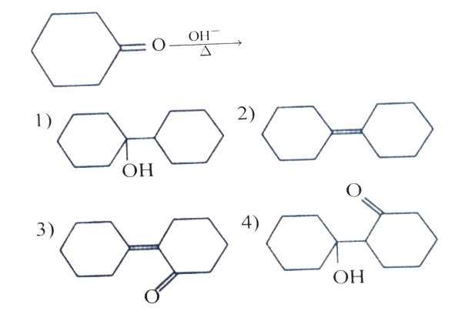

127. 

Identify the product formed



128. Compounds showing Cannizaro’s reaction are

A)  B) C) D) 

1)  2) 3) 4)



1) Formic acid 2) Formaldehyde 3) Acetaldehyde 4) Methanol

130. Which of the following will give yellow precipitate with 

1) 2)

3) 4) 

131. In the given reaction

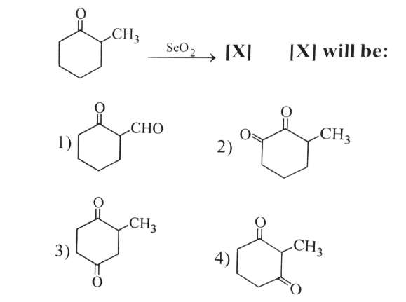

132.

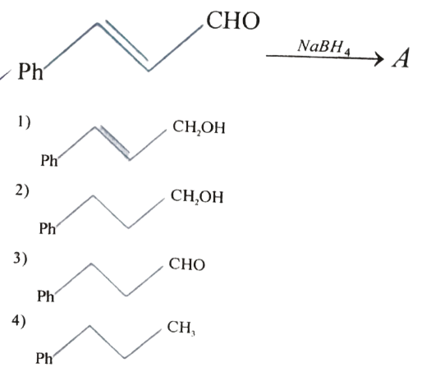

133. 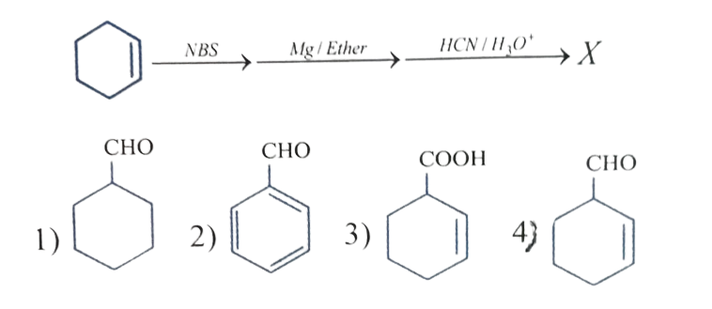

134. A mixture of benzaldehyde and formaldehyde on heating with aqueous  solution gives

1) Benzyl alcohol and sodium formate

2) Sodium benzoate and methyl alcohol

3) Sodium benzoate and sodium formate

4) Benzyl alcohol and methyl alcohol



136. 

1) Mesityl oxide 2) Diacetone alcohol 3) Acetic acid 4) Mesitylene

137. Benzaldehyde and acetone in 2: 1 molar ratio is treated with base as follows

2 benzaldehyde+acetoneProduct is

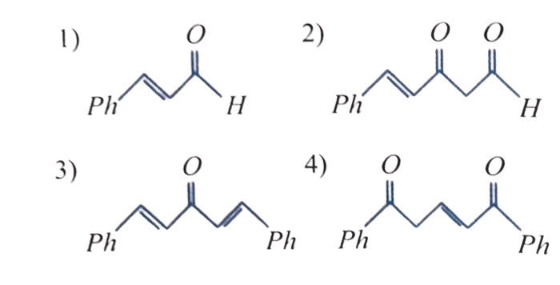

138. The acid present in red ants is

1) 2)

3) 

139. Which of the following can’t formfrom 

A) B)

C) D) MICODERMA ACETI

1) A and B only 2) C and D only 3) Only A 4) All A,B

140. In the following reaction, X and Y are respectively:



1) 2)

3) 4) 

141. . In this reaction ‘x’ is:

1) 2) 3) 4) 

142. The correct order of decreasing acid strength of trichloroacetic acid (A), trifluoro acetic acid (B), acetic acid (C) and formic acid (D) is

1)  2) 3) 4) 

143. Toluenewhat is A?

1) Acetic acid 2) Benzene 3) Benzoic acid 4) Benzaldehyde.

144. Which of the following carboxylic acids will not give HVZ reaction?

1) 2) 

3) 

145. Acetic acid reacts with ethanol in the presence ofto form ‘X’ and water which of the following is ‘X’?

1)  2) 3) 4) 

146. 

In The above series of reaction ‘Z’ is

1) 2)

3)  4)

147. In the reaction ofmay be

1) 2) 3) 4) 

148. Arrange the following in the correct order of their basic character in gaseous phase

I)  II) III)IV)

1) 2) 3) 4) 

149. Aniline when treated with benzoyl chloride, gives benzanilide the reaction is known as

1) Perkin 2) Hofmann 3) Schotten Baumann 4) Benzoin

150. 2, 4, 6-tribromo aniline is a product of

1) Electrophilic addition on 

2) Electrophilic substitution on

3) Nuclephilic addition on 

4) Nuclephilic substitution on 

151. Carbylamine reaction is given by

1) Aliphatic  amines only 2) aromatic amines only

3) Both aliphatic and aromatic primary amines 4) all secondary amines and diazonium salt

152. The Reaction is named as ……

1) Sandmeyer reaction 2) Gattermann reaction

3) Claisen reaction 4) Carbylamine reaction

153. 

Major product ‘C’ is

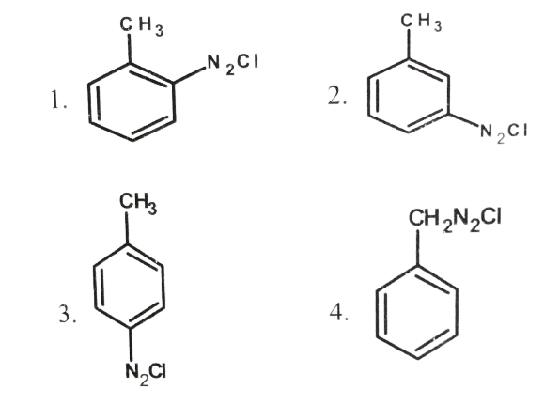

154. 

The no. ofand bonds in ‘A’ are

1)  2) 3) 4) 

155. In phenyl cyanide the carbons are____ hybridised.

1)  2) 3) 4) 

156. Which one of the following functional groups undergoes hydrolysis with alkali to yield an acid group?

1) 2) 3) 4) 

157. Ethyl chloride on heating with forms a compound (X). The functional isomer of (X) is

1) 2) 3) 4) none of these

158. In the cannizaro reaction give below 

The slowest step is

1) The attack ofat the carbonyl group.

2) The transfer of hydride to the carbonyl group

3) The abstraction of proton from the carboxylic group

4) Deprotonation of Ph.

159. The reagent which does not react with both, acetone and benzaldehyde.

1) Sodium hydrogensulphite 2) Phenyl hydrazine

3) Fehling’s solution 4) Grignard reagent

160. Acetone is distilled with concentrated. The resultant product obtained is

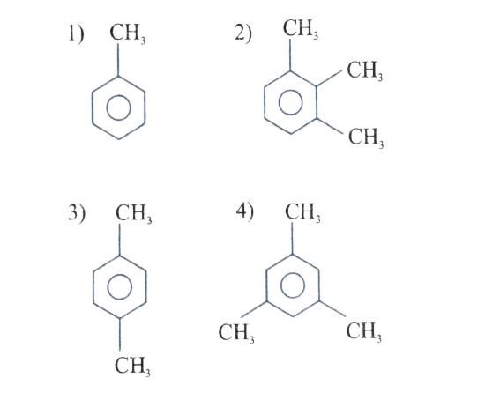

**PAPER SETTER: HYD-CP:-**

**MATHS : MR.VENUGOPAL SIR : 8919967743, 8919967743**

**PHYSICS : MR. AMRUTHAMU SIR : 9573761674**

**CHEMISTRY : MR.RAJU SIR : 9908359327**